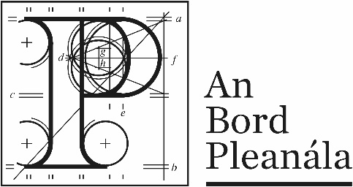
Documents received at Oral Hearing for
ABP-314232-22

Case Description | DART+ West Railway Order - Dublin City to Maynooth and M3 Parkway County Dublin, County Meath, County Kildare
Date | 10th October, 2023
Location | The Gresham Hotel, 23 O’Connell Street Upper, North City, Dublin, D01 C3W7

Documents received at Oral Hearing
No. | Submitted by | Presenter | Topic
 | Applicant | Mark Kilcullen | Module C  Slides
 | Applicant | Mark Kilcullen | Module C  1. Updates to Chapter 12 Air Quality  2.Updates to Chapter 13 Climate
 | Stephen Gartland | Stephen Gartland | Module E  Glendale Leixlip Response
 | John Spain | John Spain  Declan Hall | Module F  1.Submission  2.Addendum to Statement  3.Composite Drawing of Potential New Infrastructure & DART + West Flood Storage  4.Key policy Changes and Developments
 | Brock McClure | Luara Brock | Module F Sherwood Homes Limited – OH Statement
 | Patrick Comerford | Patrick Comerford | Module F  1.Traffic Management & Plans  2.M4 Flooding Maynooth  3.Ballycurraghan Flooding
 | Stephen Collins | Stephen Collins | Module F  1.The effects of selenium on Bloodstock Production  2.Traffic Management & Plans  3.Flooding at Jackson's Bridge

